Current league positions 2016-2017
# |  | Team | P | W | D | L | F | A | D | B | Pts
5th | Wadebridge |  | 21 | 14 | 0 | 7 | 441 | 373 | 68 | 8 | 64
6th | St Ives |  | 21 | 9 | 0 | 12 | 546 | 388 | 158 | 20 | 56

St. Ives | v | Wadebridge
Saturday 11th March 2017
KO 2:00 p.m.
at
St Ives Recreation Ground
Good afternoon to everyone as we come to the penultimate home match for St Ives in The Tribute Western Counties West league. Today’s opponents are Wadebridge Camels, to whom we extend a warm welcome.
With 4 wins in 5, Wadebridge come to St Ives in good form, albeit with wins against sides in the lower third of the league. However, their away form is on a par with St Ives’ home form. Last year they finished in 3rd place in this league.
Matches between these sides are infrequent. The last home tie was won 7:36 by the visitors on 28th March 2015. On 29th January 2011 it was all square at 19:19. You have to go all the way back to 16th March 2002 for the previous match, this time a home win, 36:12 in South West 1 West. So, a home win today would be a little bit of history. Wadebridge will want to avenge defeat earlier in the season, while St Ives will be trying to close the gap between them in the league table. It should be a tough and, hopefully, entertaining contest.
St Ives continues to notch up bonus points and now boast twenty, five more than any other team in the league. The league record is 24.
The club appreciates all its sponsors. Today we give our match sponsors, Lanhams Property Management a special mention and vote of thanks.
We also are very happy to welcome back James Milliner, our match referee. Please accord him respect for his willingness to officiate.
Do join us in the clubhouse before the match, at half time or after the match, for refreshment and to watch England.
Alan Thomas
Today’s Tribute Western Counties West League fixtures
Crediton |  |  | Truro
Cullompton |  |  | Burnham-on-Sea
Devonport Services |  |  | Tiverton
Exeter University |  |  | St Austell
St Ives (SW) |  |  | Wadebridge Camels
Torquay Athletic |  |  | Sidmouth
Wellington |  |  | Bude
Fixture list
Sat. 18th March | No match : final RBS 6 Nations matches
Sat. 25th March | Bude | Away
Sat. 5th April | Wellington | Away
Recent Hakes results
(since last match programme)
Sat. 18th Feb 2017
St Ives 39:5 Burnham-on-Sea (try bonus)
Sat. 4th March 2017
Truro 15:10 St Ives (losing bonus)

Match previews, reports, news, results, league table
and much more on the club website:
www.stivesswrfc.co.uk
and on our Facebook page:
https://www.facebook.com/StIvesRFCHakes/

Flashback:
Sat. 19th Nov. 2016
Wadebridge Camels 18
St Ives 22

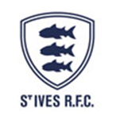 | 

St Ives  Hakes |  | V | Wadebridge Camels  Western Counties West league table after week twenty one (no draws recorded)  # Team Pl HW HL AW AL W L F A Diff Pts Adj  1 Exeter Uni 21 9 1 8 3 17 4 751 301 450 83 15  2 Cullompton 21 10 0 7 4 17 4 483 267 216 76 8  3 Devonport 21 7 3 8 3 15 6 470 361 109 68 8  4 Truro 20 9 2 5 4 14 6 535 394 141 68 12  5 Wadebridge 21 8 3 6 4 14 7 441 373 68 64 8  6 St Ives 21 6 5 3 7 9 12 547 388 159 56 20  7 Sidmouth 21 6 4 4 7 10 11 500 476 24 50 10  8 Torquay 21 6 4 4 7 10 11 371 490 -119 49 9  9 St Austell 21 6 4 3 8 9 12 429 419 10 49 13  10 Tiverton 21 6 5 1 9 7 14 291 478 -187 36 8  11 Burnham 20 6 4 0 10 6 14 314 396 -82 35 11  12 Bude 21 6 5 0 10 6 15 325 746 -421 30 6  13 Crediton 21 5 5 0 11 5 16 329 465 -136 30 10  14 Wellington 21 6 5 1 9 7 14 293 525 -232 27 -1  So what’s all this about bonus points?  St Ives has gained a noteworthy and important 20 bonus points so far this season. It is not yet a record for a Cornish side, (or any team in the south west), but it could be with five games still to be played. The bonus point system of a point for scoring four or more tries and a point for not losing by more than 7pts was first introduced at national league level in 2006-07. At the time St Ives were in South West 1 and achieved 23pts from 22 games; W11 D1 L10.  It was not until 2010-11 that the system was adopted across all leagues. Very few teams outside the top two gain the most in any one season. Cambridge created a record of 25BP from 29 games, when finishing 3rd in NL1 (2010-11).  In 2013-14 Hartbury College won NL2 (South) with 25BPfrom 26 matches. The record in Western Counties West is 24pts set by Ivybridge when they won the league in 2013-14.  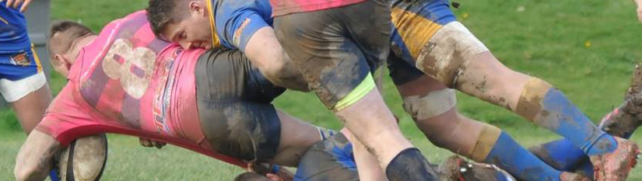
Tom Chandler |  | 1 | Christian Cotton
Joel Stevens |  | 2 | Matt Ballard
Ben Taylor |  | 3 | Jack Scott
Joe Burton |  | 4 | Corey Teague
Harry Parton |  | 5 | Richard Dawe
Archie Mackay |  | 6 | Harry Smith
Sean Stevens |  | 7 | Adam Blackmore
Martin Lawrence |  | 8 | Hugo Culverhouse
Liam Jolly |  | 9 | Adam Collings
Grant Thirlby |  | 10 | James Grubb
Lewis Thomas |  | 11 | Dom Hawkey
Steve Kenward |  | 12 | Danny Thomas
Tom Nicholas |  | 13 | Callum Wilson
Jacob Ninnes |  | 14 | Rhys Bright
Jordan Gott |  | 15 | Will Pengelley
Replacements
Peter Skeggs | 16 |  | Zac Cinnamond
Peter Mabbott | 17 |  | Jacob Johns
Joe Parma | 18 |  | Ben Hawken
Referee: James Milliner (CRRS)
Burnham-on-Sea match photos on the website gallery,
also an archive album of team photos. Go to www.stivesswrfc.co.uk

Catering For You…..
Please make use of the food and hot drinks available in the clubhouse. Thank you, Saskia.

