|  |  |  |  |  |  |  |  |  |  |
| --- | --- | --- | --- | --- | --- | --- | --- | --- | --- |
| **League positions** | | | | | | | | | |
|  |  | P | W | D | L | F | A | D | Pts |
| 6 | Devonport Services | 8 | 4 | 1 | 3 | 175 | 158 | 17 | 23 |
| 13 | St Ives | 8 | 1 | 0 | 7 | 129 | 252 | -123 | 7 |

|  |
| --- |
| **Today’s Tribute Western Counties West League fixtures** |
| |  |  |  |  | | --- | --- | --- | --- | | Okehampton |  |  | Burnham-on-Sea | | Paignton Saxons |  |  | Wellington | | Penryn |  |  | Ivybridge | | St Ives (SW) |  |  | **Devonport Services** | | Tavistock |  |  | Bude | | Teignmouth |  |  | Kingsbridge | | Torquay Athletic |  |  | Truro | |



**St Ives v Devonport Services**

Saturday 2nd November 2013

KO 2:30 p.m.

**at**

St Ives Recreation Ground

It is with great pleasure that St Ives RFC welcomes regular visitors, Devonport Services RFC, to Alexandra Road. The Plymouth based club provides rugby for the men and women of the armed services of the U.K., mainly the Royal Navy and the Royal Marines.

The Western Morning News reported over one hundred years ago that, *“It is a pity the Services have to make so many changes in their team week by week, for their combination suffers badly and all things considered it is remarkable they should make such a good showing against the representative clubs they meet.”*

This week St Ives coach, Rob Elloway commented*, “I think a lot will depend on their player availability because of the type of club they are.”*

Today’s match promises to be a tough encounter, both sides believing that points are there for the taking. St. Ives almost came away with a win at Bude last week, but for a disallowed try in the closing minutes. Devonport managed a narrow five point victory at the same venue. With Bude facing a visit to Tavistock, just one place above them in the league, a win for St. Ives will put them in a much healthier position. Ironically, player availability will also be critical for the home side today.  
Ryan Cook of CRRS is our match official today. We hope he enjoys the afternoon.

*Alan Thomas*

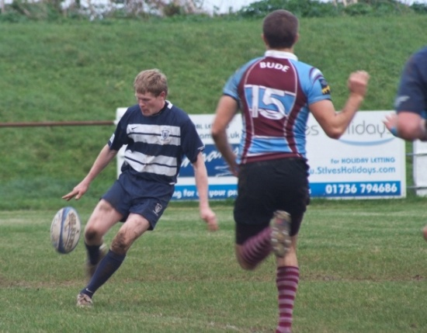

Rob Rowe clears from his own 22 during the 2011 fixture against Bude.

*(Photo courtesy of Mike Cullin)*

**Reminder:**

Now the clocks have gone back one hour to GMT, kick off time has moved to 2:30p.m.

**Next fixtures:**

**Saturday 9th November 2013**

St Ives v Ivybridge

**Next home fixture:**

**Saturday 23rd November 2013**

St Ives v Wellington

Tower of strength, **Neil Corin**, with an average of one try in each of his 11 appearances, is setting high standards as leading try scorer among the forwards

|  |  |  |  |  |  |  |  |  |  |  |  |  |  |  |  |  |  |  |  |  |  |  |  |  |  |  |  |  |  |  |  |  |  |  |  |  |  |  |  |  |  |  |  |  |  |  |  |  |  |  |  |  |  |  |  |  |
| --- | --- | --- | --- | --- | --- | --- | --- | --- | --- | --- | --- | --- | --- | --- | --- | --- | --- | --- | --- | --- | --- | --- | --- | --- | --- | --- | --- | --- | --- | --- | --- | --- | --- | --- | --- | --- | --- | --- | --- | --- | --- | --- | --- | --- | --- | --- | --- | --- | --- | --- | --- | --- | --- | --- | --- | --- |
| St Ives | V | Devonport  **A bit of history**  I am indebted to the Devonport Services website for the following table showing how points awarded has altered significantly over the years. Up until 1905 your score did not count until a goal had been kicked, thus if you scored 3 unconverted tries to a penalty, you lost 3:0. I am not sure what GMs are. Could it be a goal from a mark?   |  |  |  |  |  |  | | --- | --- | --- | --- | --- | --- | | **Period** | **Try** | **Con** | **DG** | **PG** | **GM** | | 1890/1891 | 1 | 2 | 3 | 2 | 3 | | 1891/92~1892/93 | 1 | 3 | 4 | 3 | 4 | | 1893/94~1904/05 | 2 | 2 | 4 | 3 | 4 | | 1905/06~1947~48 | 3 | 2 | 4 | 3 | 3 | | 1948/49~1970/71 | 3 | 2 | 3 | 3 | 3 | | 1971/72~1976/77 | 4 | 2 | 3 | 3 | 3 | | 1977/78~1991/92 | 4 | 2 | 3 | 3 | - | | 1992/93~ present | 5 | 2 | 3 | 3 | - |   I recall playing scrum half for the colts back in the early 1970s against the Bude senior team, the last season of only three points for a try. A lip through a tooth due to an inaccurate punch in a scrum from our only ‘adult’, playing flanker is a memory that left its mark in a cow field with a barb wire surround. How times have changed.  A final reminiscence and puzzle: In 1933-34 St. Ives scored 2 tries to Devonport Services’ 1 try and a dropped goal. Who won? In that same season St. Ives scored 85 tries, but only 4 penalties! Dropped gaols were nine. Indeed, how times have changed.  Finally, the club is pleased you decided to watch live rugby on a day when the autumn internationals begin. |
|  | 1 | Declan Sexton |
|  | 2 | Sam Bennett |
|  | 3 | Olly Dugmore |
|  | 4 | Rocky Young |
|  | 5 | John Mellor |
|  | 6 | Ed Northcott |
|  | 7 | Mike Scott |
|  | 8 | Dave Chorley |
|  | 9 | Tom Smyth |
|  | 10 | Charlie Attis |
|  | 11 | Matt Morrison |
|  | 12 | Scott Williams |
|  | 13 | Callum Perkins |
|  | 14 | Ben McGowan |
|  | 15 | Matt Morrison |
| Replacements | | |
|  | 16 | Tom Bailey |
|  | 17 | Josh Morrison |
|  | 18 | Manoa Tickoisuva |
| Referee: Mr Ryan Cook (CRRS) | | |

